**Exercise 1**

**Question 1**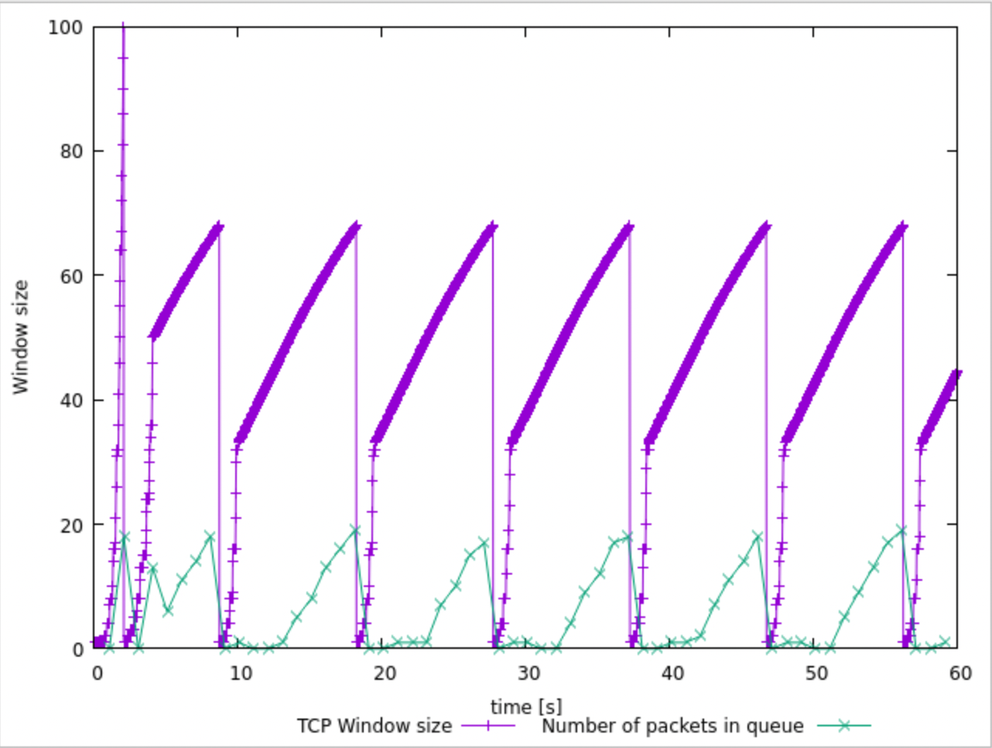

1. In this case, what is the maximum size of the congestion window that the TCP flow reaches?

The maximum size of the congestion window that the TCP flow reaches is 100.

1. What does the TCP flow do when the congestion window reaches this value? Why?

When the congestion flow reaches this value the congestion window is dropped to 1, and the threshold is set to half of 100, 50. This happens after timeout or triple dup ACK.

1. What happens next?

Another slow-start stage begins again until it reaches the threshold.

**Question 2:** From the simulation script we used, we know that the packet's payload is 500 Bytes. Keep in mind that the size of the IP and TCP headers is 20 Bytes each. Neglect any other headers. What is the average throughput of TCP in this case? (both in number of packets per second and bps)

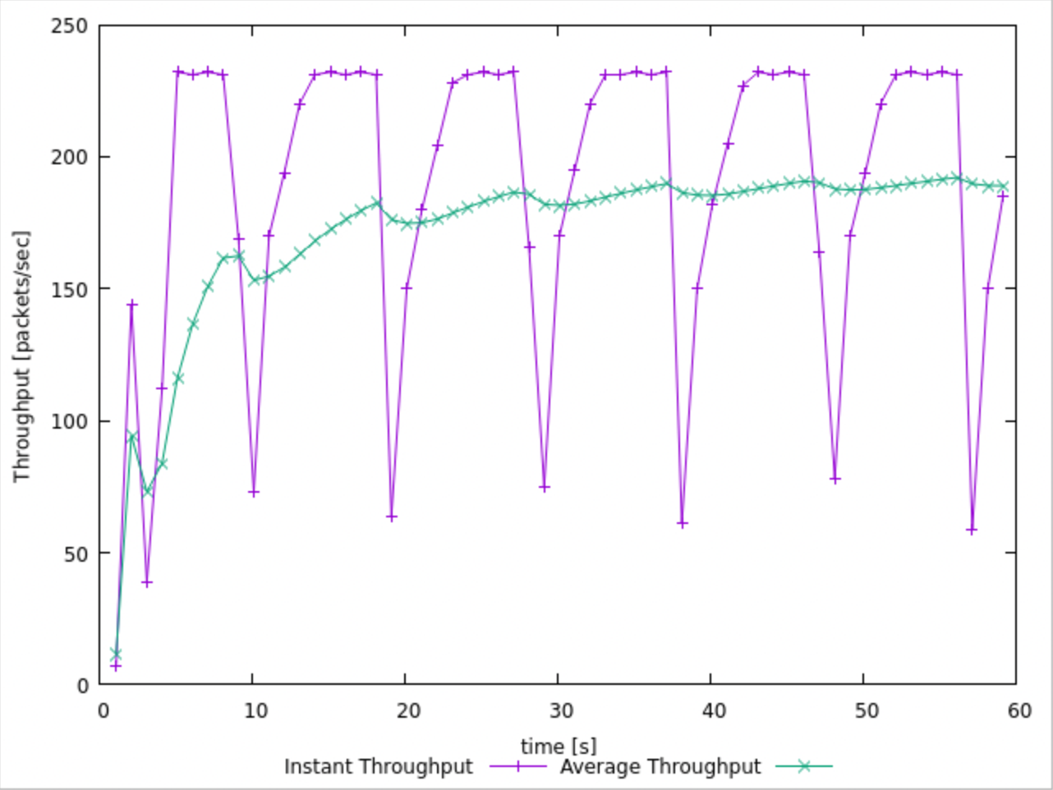

From the graph the average Throughput is 188.418 packets per second. In bytes per second, the average throughput is 188.418 * (500+20+20) = 101745.72Bps. In bits per second, the average throughput is 813965.76 bps.

**Question 3:** Rerun the above script, each time with different values for the max congestion window size but the same RTT (i.e. 100ms).

|  |  |
| --- | --- |
| 40 |  |
| 50 |  |
| 60 |  |
| 70 |  |

1. How does TCP respond to the variation of this parameter?

The oscillations are increasing as the window size is increasing.

1. Find the value of the maximum congestion window at which TCP stops oscillating (i.e., does not move up and down again) to reach a stable behaviour.

For our graphs the maximum congestion window is 50.

1. What is the average throughput (in packets and bps) at this point?

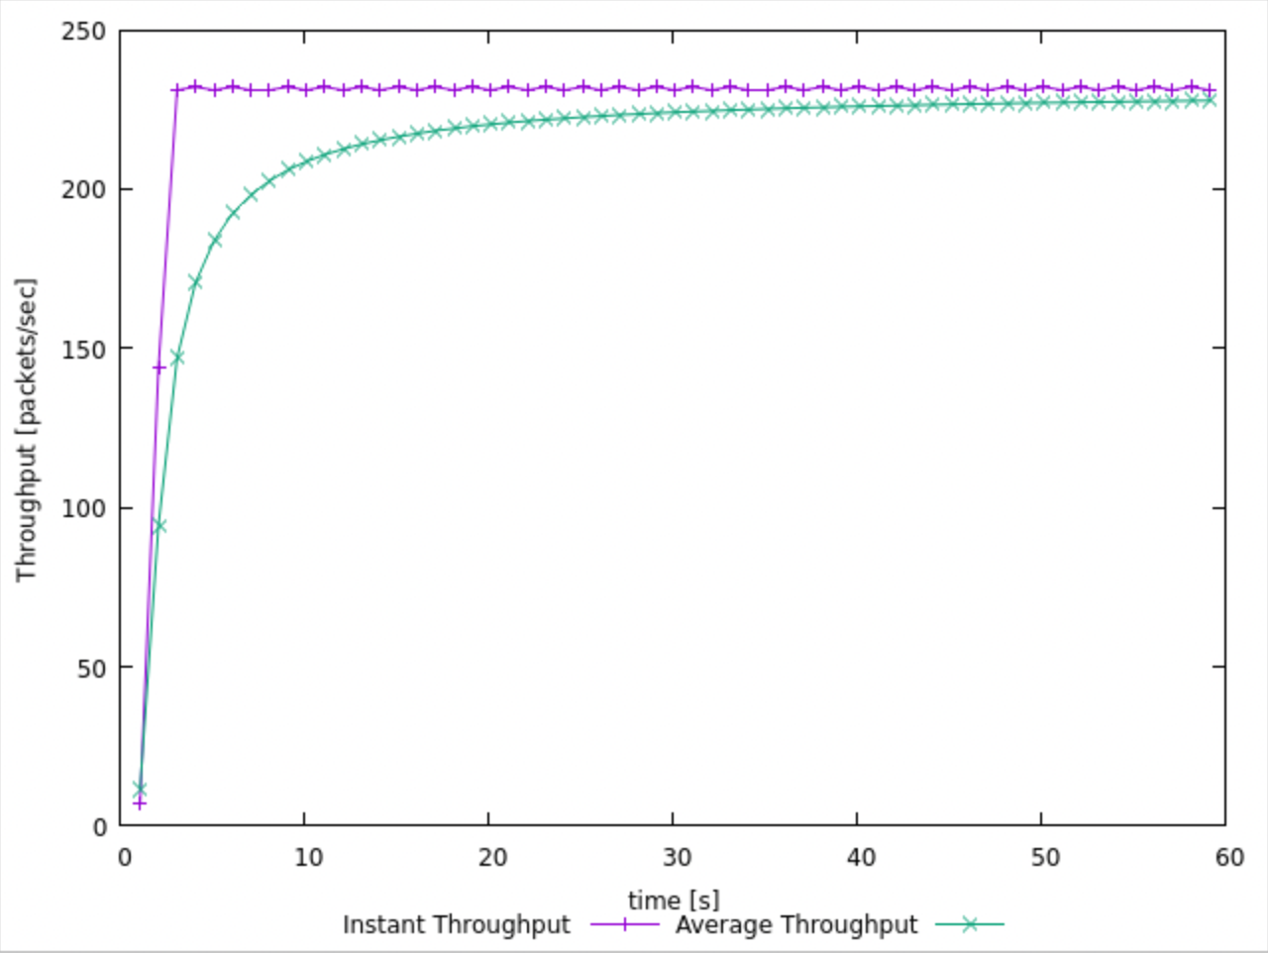

From the graph the average throughput in packets is 225.118. In bps this is 225.118 * 540 * 8 = 972509.76bps.

1. How does the actual average throughput compare to the link capacity (1Mbps)?

The actual average throughput is quite close to 1Mbps.

100 * (0.972/1) = 97.2%

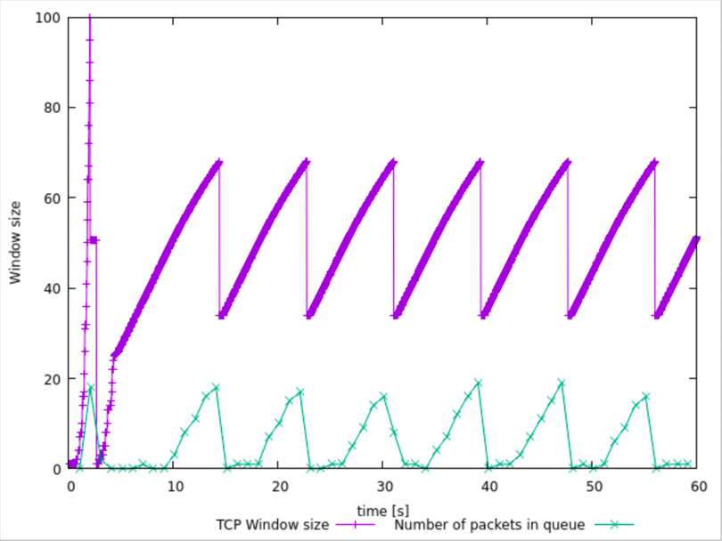**Question 4:** Repeat the steps outlined in Questions 1 and 2 (NOT Question 3) but for TCP Reno. Compare the graphs for the two implementations and explain the differences. (Hint: compare the number of times the congestion window returns to zero in each case). How does the average throughput differ in both implementations?

Reno only hits 0 once after slow-start. When Reno meets a congestion event it halves the current window and skips slow-start stage. The average throughput of Reno is also higher being 203.412 compared to 188.418.

**Exercise 2**

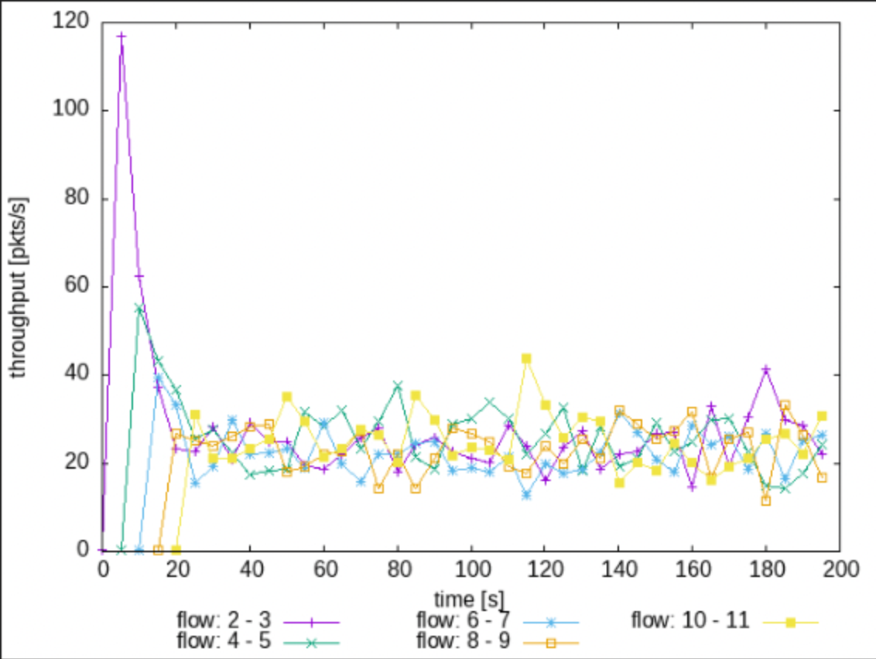

**Question 1:** Does each flow get an equal share of the capacity of the common link (i.e., is TCP fair)? Explain which observations lead you to this conclusion.

Yes, each flow gets an equal share of the capacity of the common link. At the start(0-20s) each flow does not have an equal share of the common link. However, as time increases each flow starts fluctuating to average between 20 and 40 packets.

**Question 2.** What happens to the throughput of the pre-existing TCP flows when a new flow is created? Explain the mechanisms of TCP which contribute to this behaviour. Argue whether you consider this behaviour to be fair or unfair.

When a new flow is created the throughput of pre-existing TCP flows is decreased. The mechanism of TCP which contributes to this behaviour is slow-start of a new flow which creates congestion. Due to this congestion the pre-existing TCP flows decrease their windows. This behaviour is fair, as it divides the common link more after this behaviour.

**Exercise 3**

**Question 1:** How do you expect the TCP flow and the UDP flow to behave if the link's capacity is 5 Mbps?

UDP will have a higher throughput than TCP as UDP does not have any congestion control mechanisms. 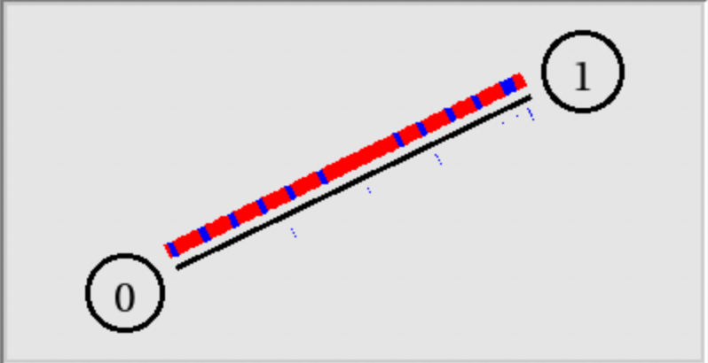

The script will open the NAM window. Play the simulation. You can speed up the simulation by increasing the step size in the right corner. You will observe packets with two different colours depicting the UDP and TCP flow. Can you guess which colour represents the UDP flow and the TCP flow, respectively?

Red is UDP and the blue is TCP.

Plot the throughput of the two flows using the above script (TCPUDP_pps.plot) and answer the following questions:

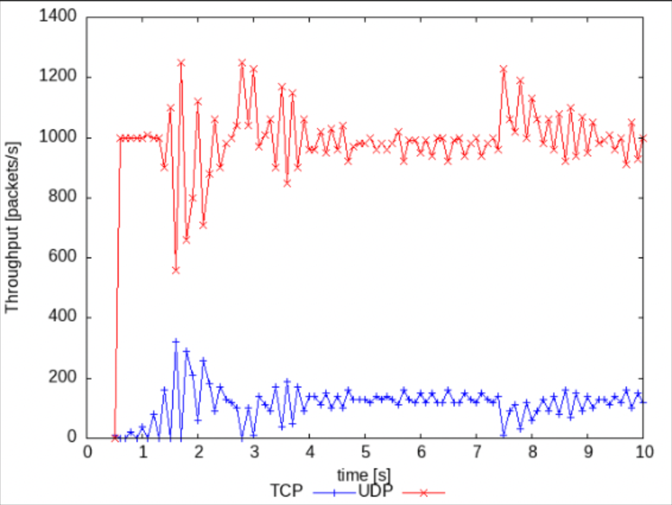

**Question 2:** Why does one flow achieve higher throughput than the other? Try to explain what mechanisms force the two flows to stabilise to the observed throughput.

UDP achieves a higher throughput than TCP because it does not have congestion control and thus sends packets at a constant rate, which may result in packet loss. TCP is more reliable than UDP, however it does this by changing the window sizes and using congestion control which makes it slower.

**Question 3:** List the advantages and the disadvantages of using UDP instead of TCP for a file transfer, when our connection has to compete with other flows for the same link. What would happen if everybody started using UDP instead of TCP for that same reason?

Advantages:

* Higher throughput
* Constant transfer rate
* Less headers and smaller packet size

Disadvantages:

* No congestion control
* May be data loss
* Packets not in order.

If everyone started using UDP there would be a lot of packet loss when sending files which would result in corrupted files. Furthermore, networks will be overwhelmed with no limit on transmission rates.